Tutorial on Submitting Files Using Nutstore

Check the website link
Use https://send2me.cn/NUhEceOf/Tz61i8BRy0q_7A

Submit your report and source code
Step 1: Change your language to English first
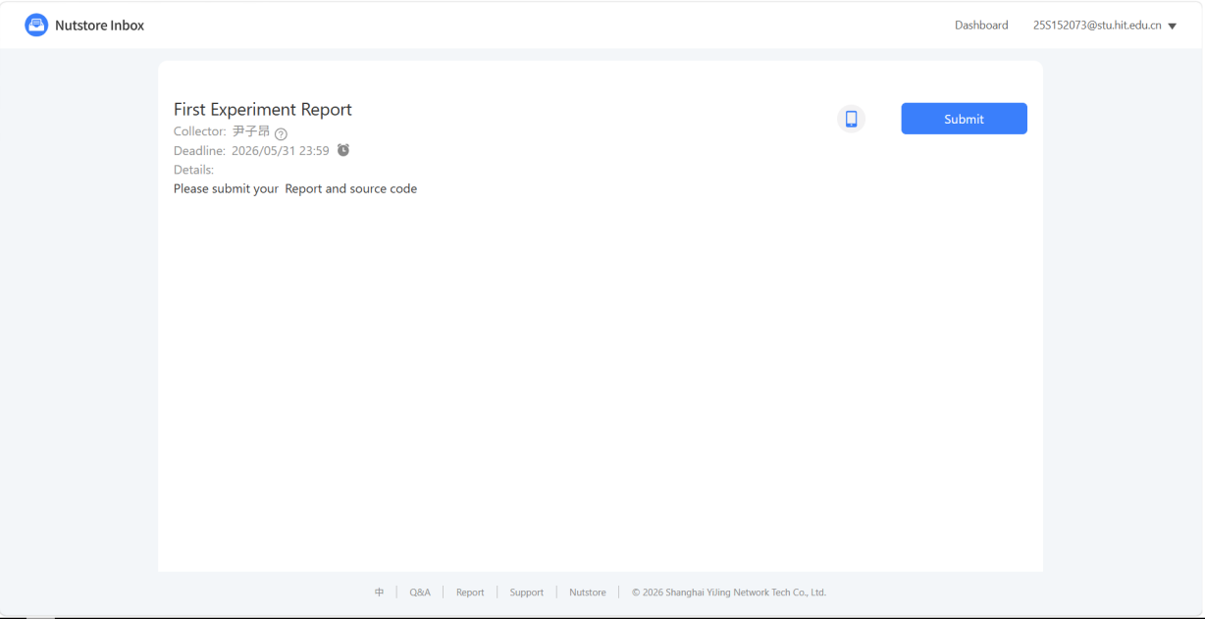

Step 2： click “submit”

Step 3： Enter your name and student ID .For example: mike 25SF00000

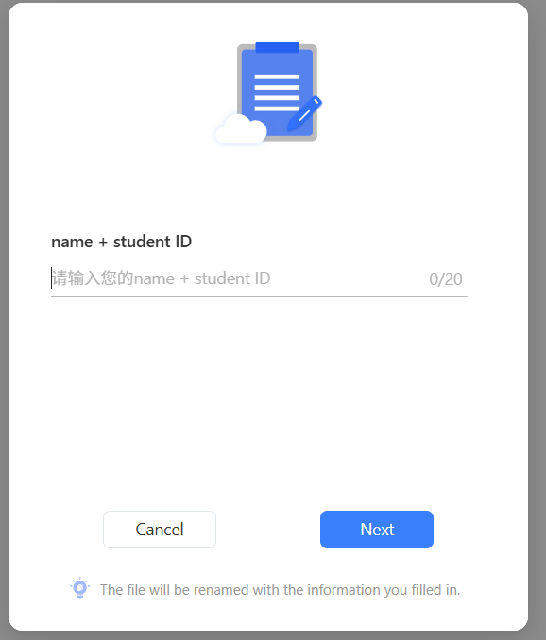

Step 4: Submit your report and source code together in the form of a compressed package.(.zip)

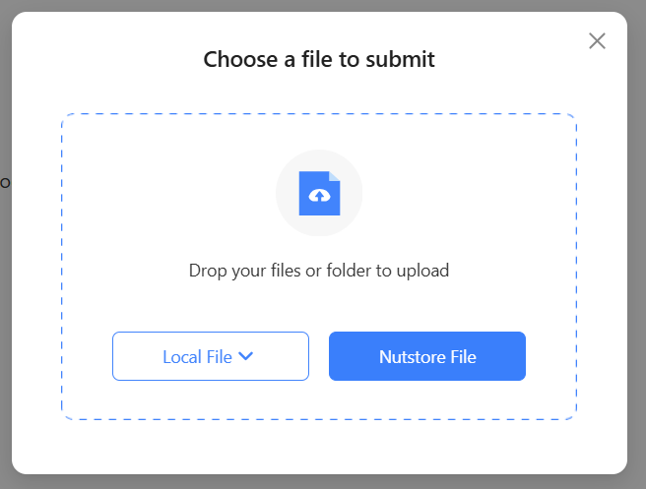

Save the submission proof to avoid losing the file

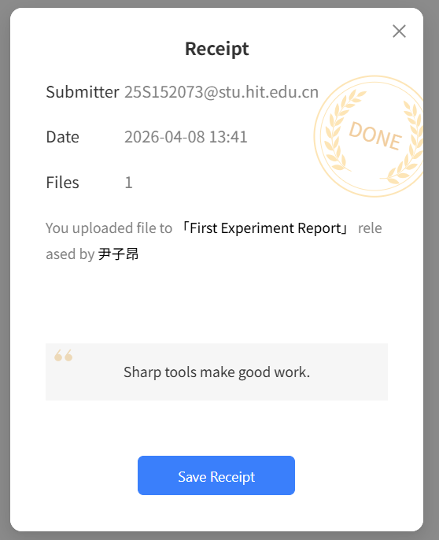
NOTE：Ensure that the proof save window pops up. If you cannot submit, please contact the teaching assistant; otherwise, there will be no grade for this project！！

